**University of Southern Indiana**

**CIS376 - Intermediate Web Development**

**Exercise 01**

**1. Create a folder called Your Last Name_Your First Name (that is your actual last name and first name). For instance my folder would be called Nolan_Ernie.**

**a. Inside this folder create the following folders:**

**1. A folder called Images. All images required for this class should be placed in this folder.**

**2. A folder called Styles. All style sheets required for this class should be placed in this folder.**

**3. A folder called Scripts. All JavaScript files (.js file extension) required for this class should be placed in this folder.**

**4. A folder called Pages. All web pages (.html file extension) required for this class (except Index.html) should be placed in this folder.**

**b. All assignments are turned in via Blackboard. When I grade them, I will go to your folder and click on Index.html and I should be able to access all of your assignments.**

**2. Use file Template – Transitional to create a page called Index.html that contains/does the following:**

**a. Displays an image (of your choice) in the Header Section.**

**b. Uses a CSS sheet called Index.css to control the formatting of the Page, Header, Body and Footer <div> tags.**

**c. Displays “CIS376 – Programming for Enterprise Web Development” in the Header <div> tag, inside an <h1> tag.**

**d. Displays “Class Menu” and “Your Name” in the Header <div> tag, inside a <p> tag.**

**e. Create a link to “Exercise01.html” with the following text; “Assignment 1”, in the Body <div> tag.**

**f. Displays the “Copyright symbol along with the words “Copyright” along with the name of your “company/enterprise”, in the Footer <div> tag.**

**Index.html should look something like the example below:**

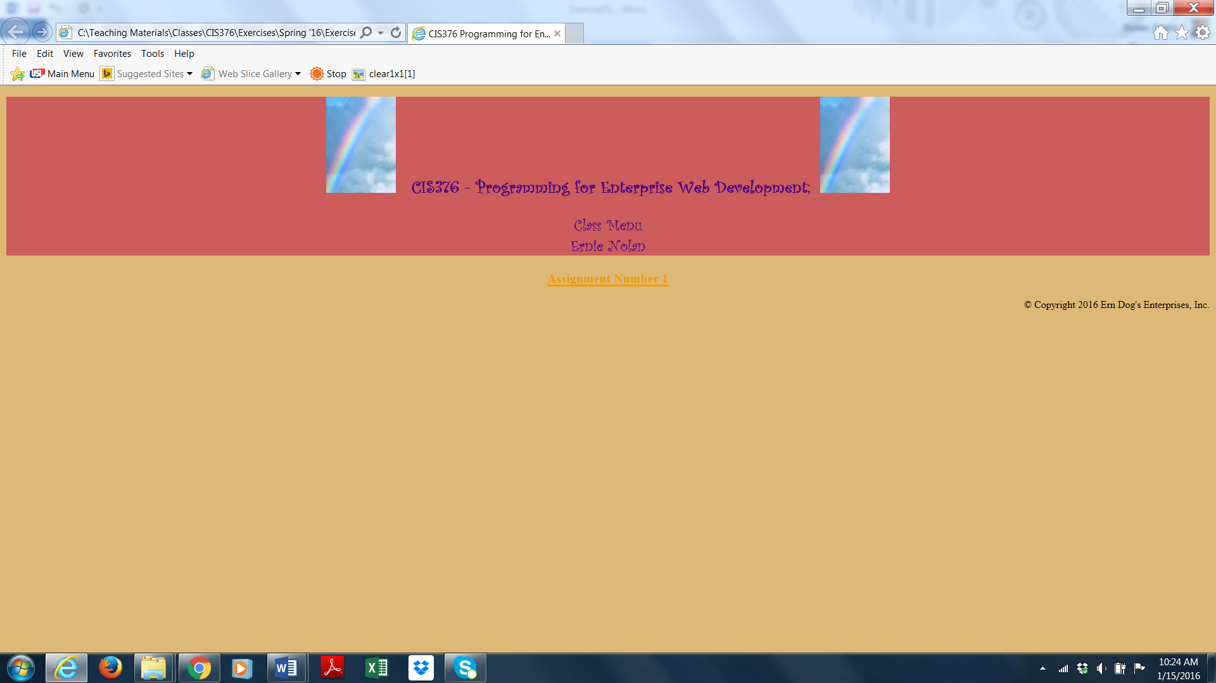

**3. Exercise01.html should have four links to four “conversion” html pages along with a return link to Index.htm. Exercise01.html should look similar to the example below:**

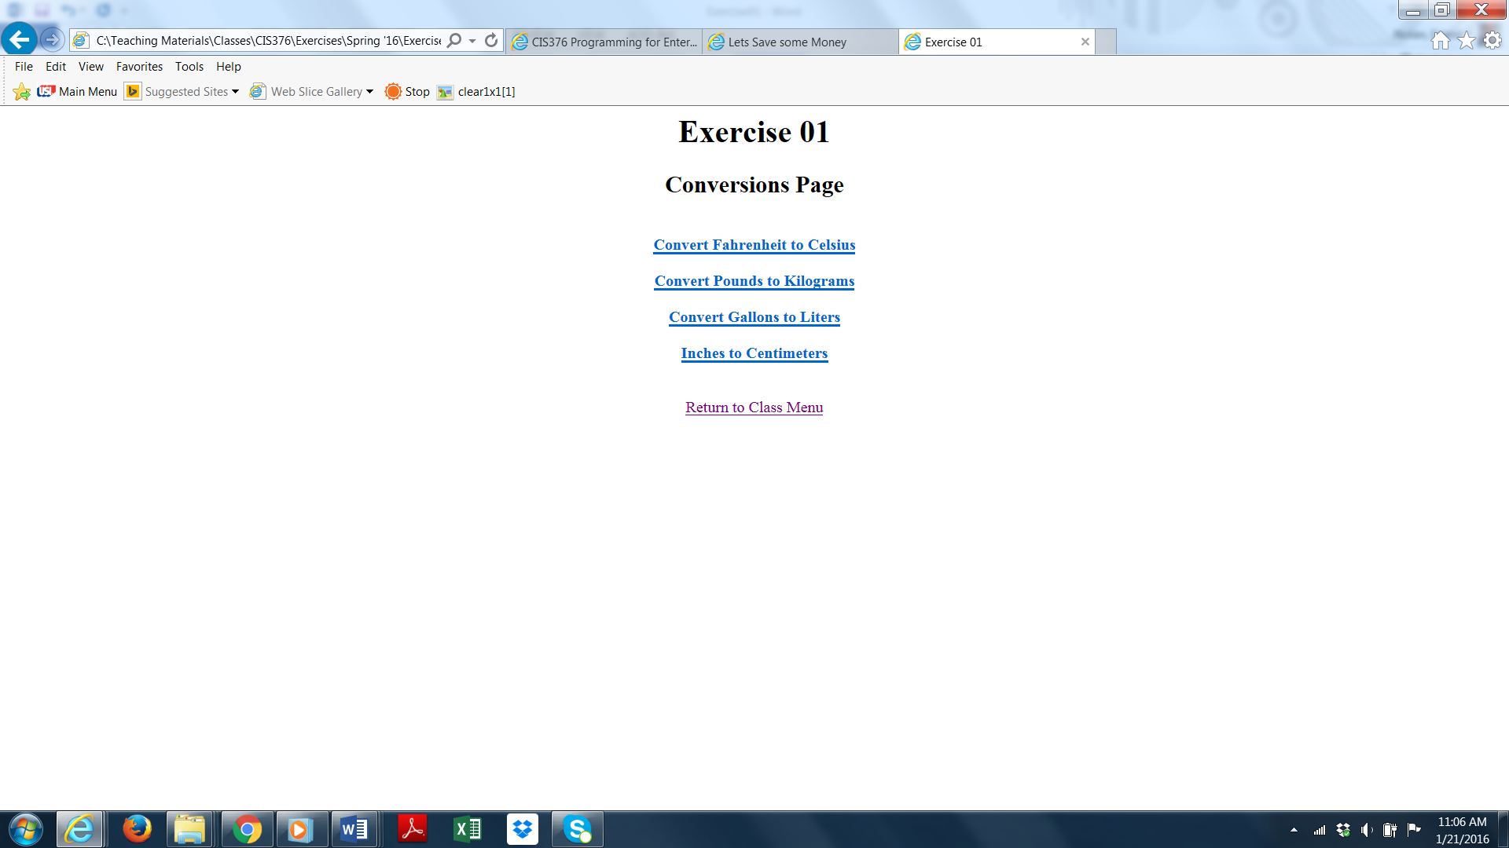

**4. Each of the individual conversion pages should have a form setup to allow the user to convert something from one unit of measure to another. In addition, the pages should have a “Convert” button, a “Refresh Page” button and a return link to the main Conversions page. Each individual conversion page should look similar to the example below:**

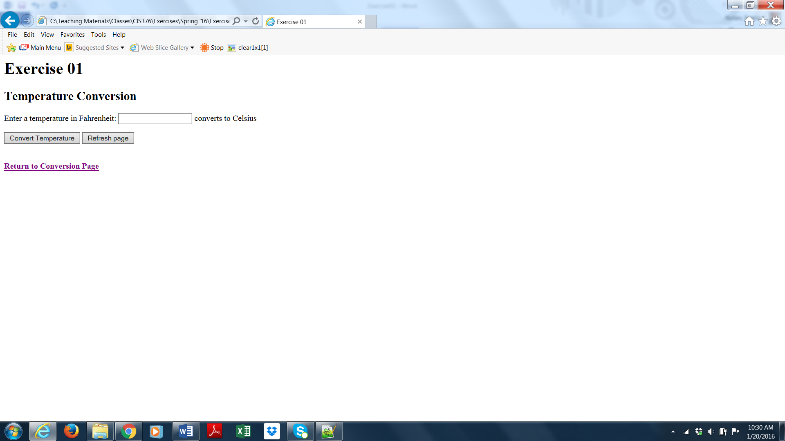

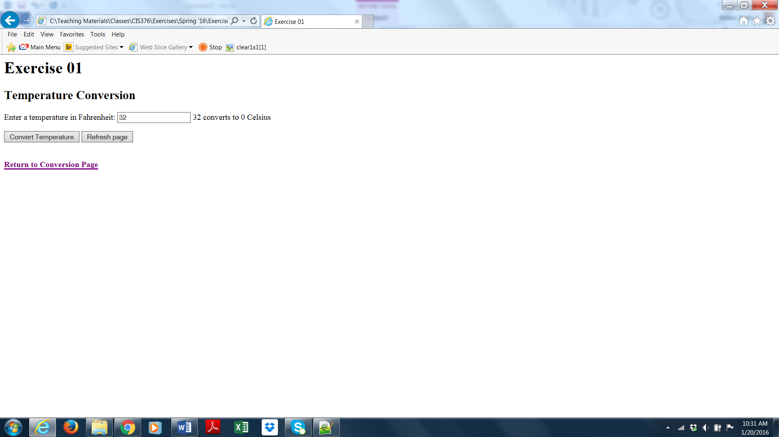

**5. The JavaScript code used to do the conversions should validate the input as not being blank and being numeric. In addition, the JavaScript code should issue an alert with an appropriate error message.**

**6. Create pages and scripts to convert Fahrenheit to Celsius, Pounds to Kilograms, Gallons to Liters and Inches to Centimeters.**

**7. Conversion Formulas:**

**celsius = Math.round(((fahrenheit-32)*5/9)*100)/100**

**kilograms = Math.round((pounds/2.2)*100)/100**

**liters = Math.round((gallons * 3.785411)*100)/100**

**centimeters = Math.round((inches * 2.54)*100)/100**

**8. Feel free to make the pages look “awesome” by using appropriate colors, images and animation.**

**This assignment is due 09/09/16 at 11:30 AM and is worth 50 points.**